I started my analysis with brainstorming

Before I could use the data below I had to export the Delimit the date and the time separately so that I can upload on Snowflake correctly.

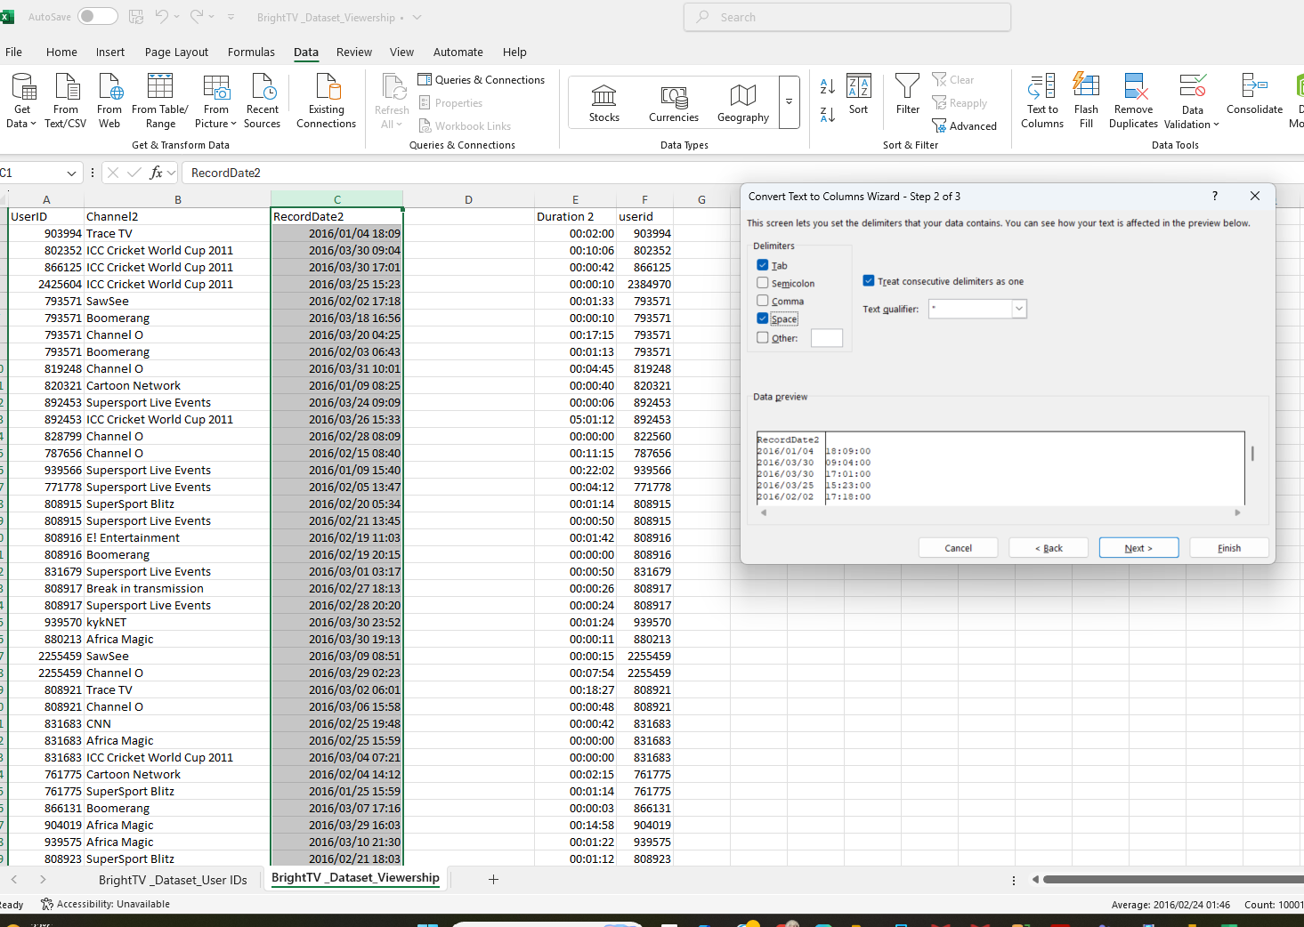

Let’s start to code to amend the data set

USE Full inner join to add the two data 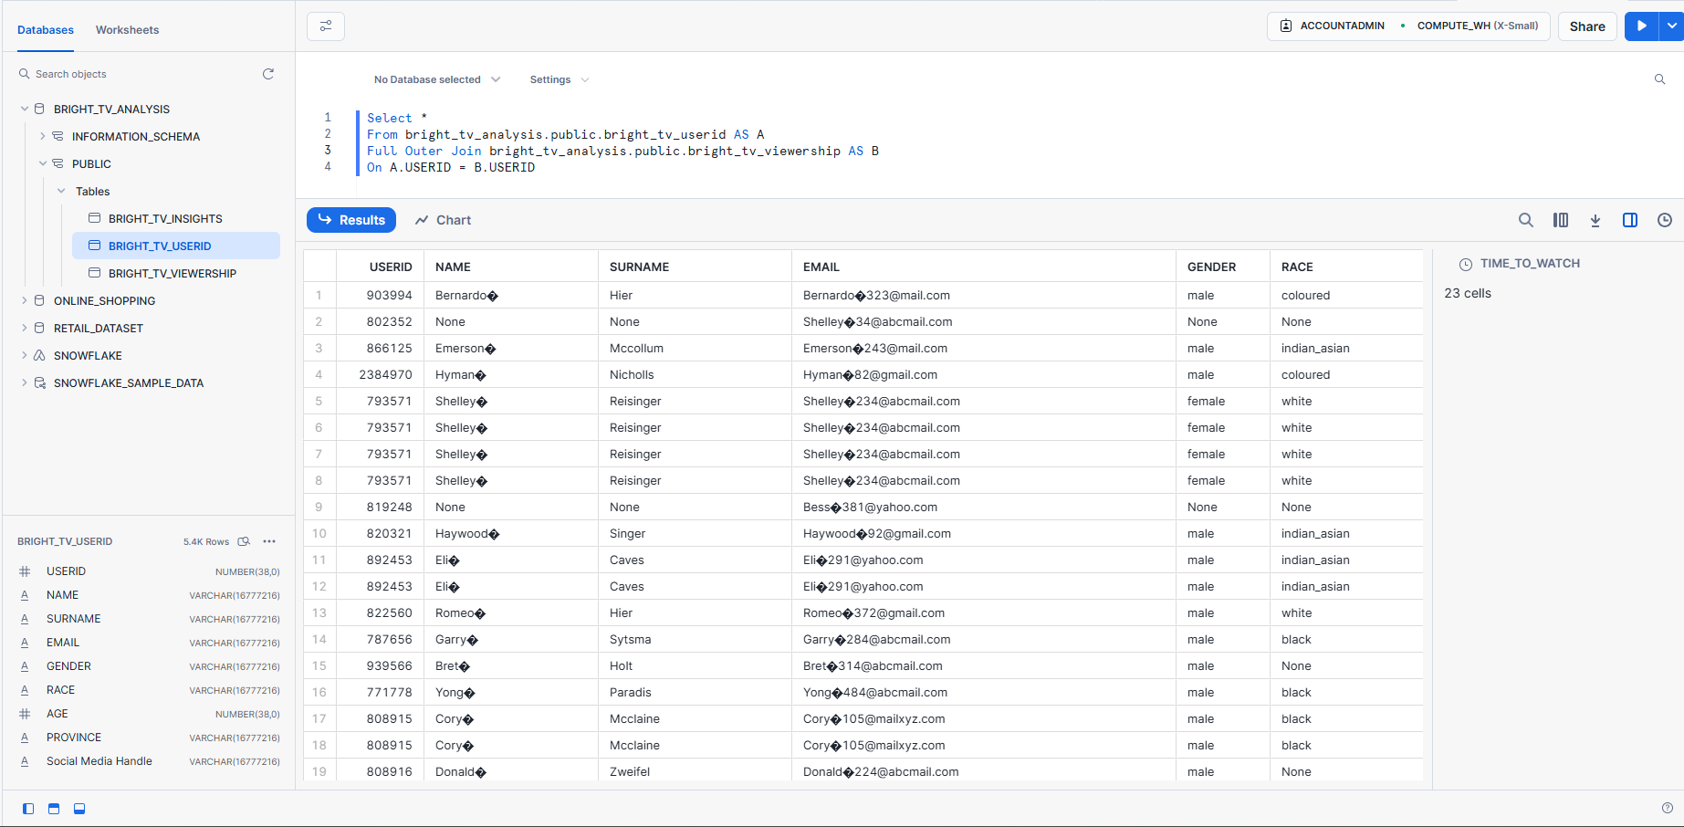

I will the first Case Conditions ‘Age’ to add a new column as Age_demographics

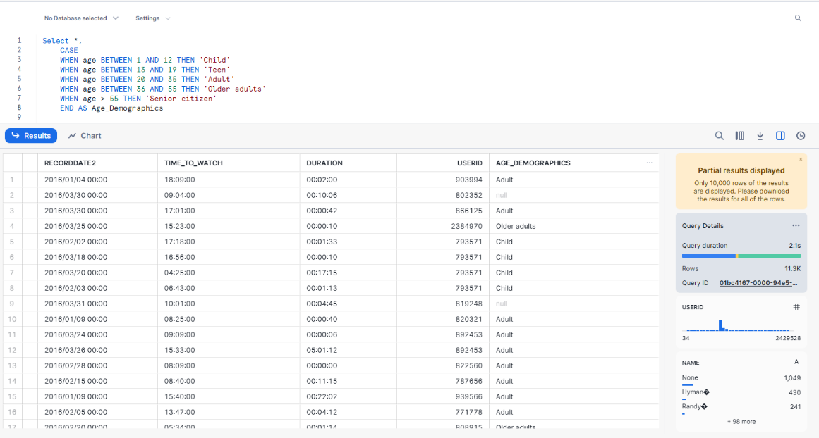

Second Case Conditions ‘Time_to_watch to add a new column as Time buckets 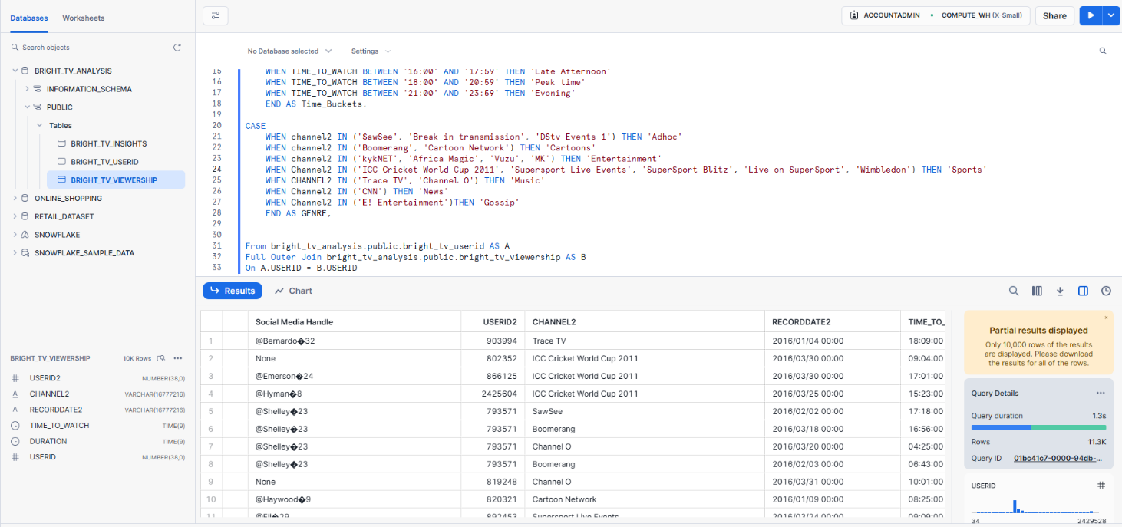

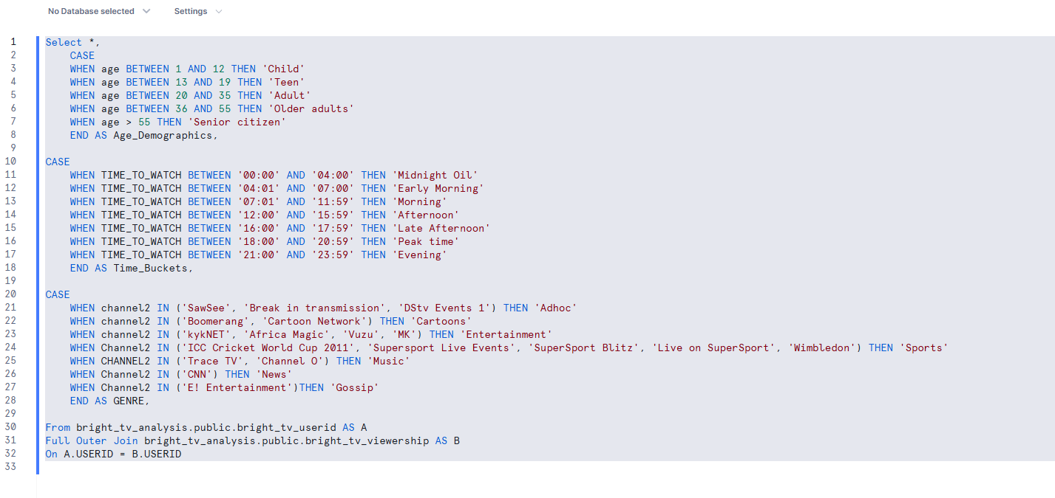Third Case Conditions: Categorize Segments into “Genre”

I will export the data and Use Excel to Analyse

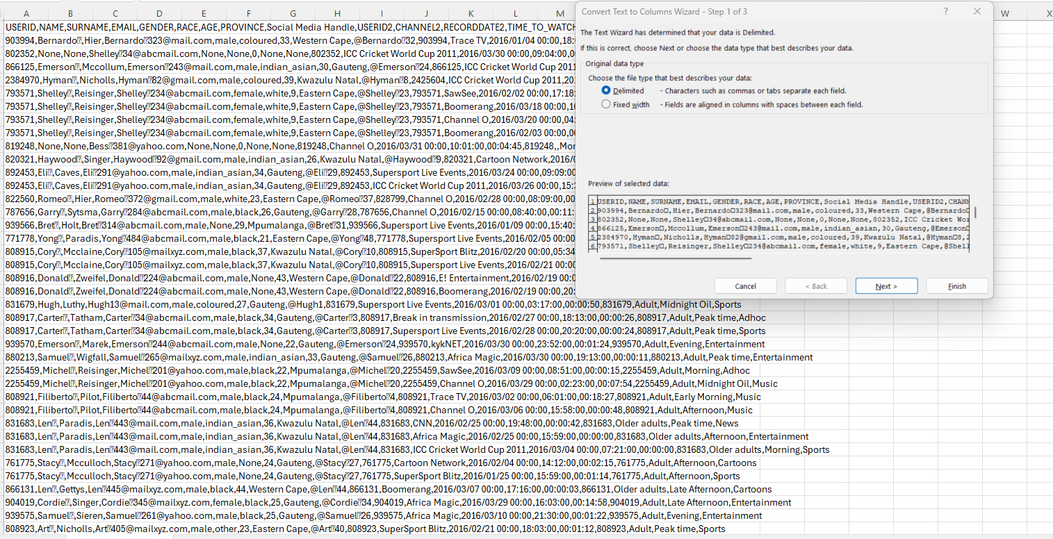

Cleaning Data

All Age Demographic that has a null value is written “Unknown”

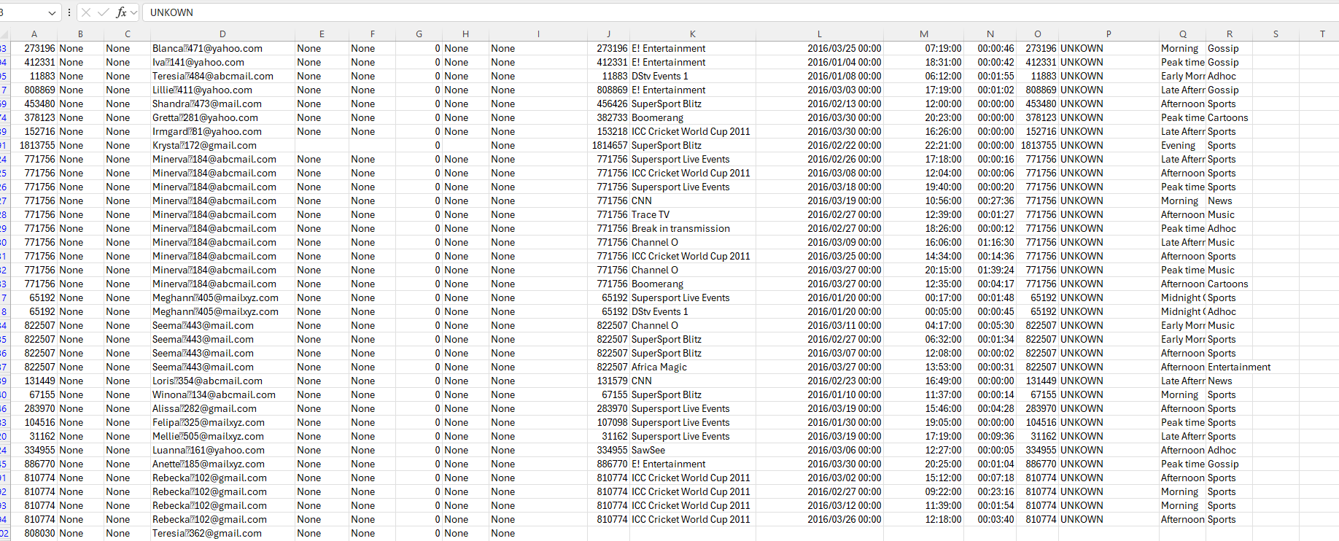

Lets Analyse : Gender

**Pivot Rows:** Gender, **Pivot Values**: Count of USERIDS2 : Pie Chart

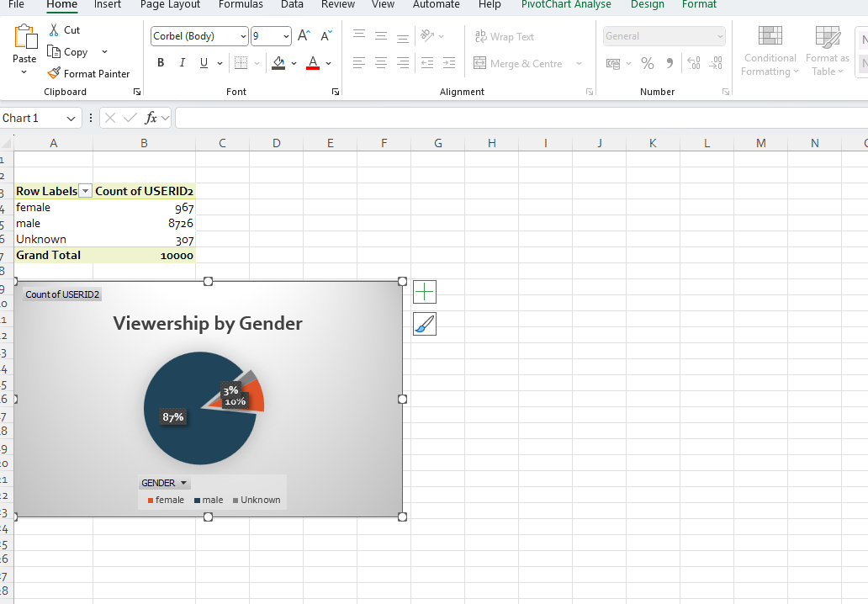

Lets Analyse : Age

**Pivot Rows:** Age by Demographics, **Pivot Values**: Count of USERIDS2 : Bar Chart

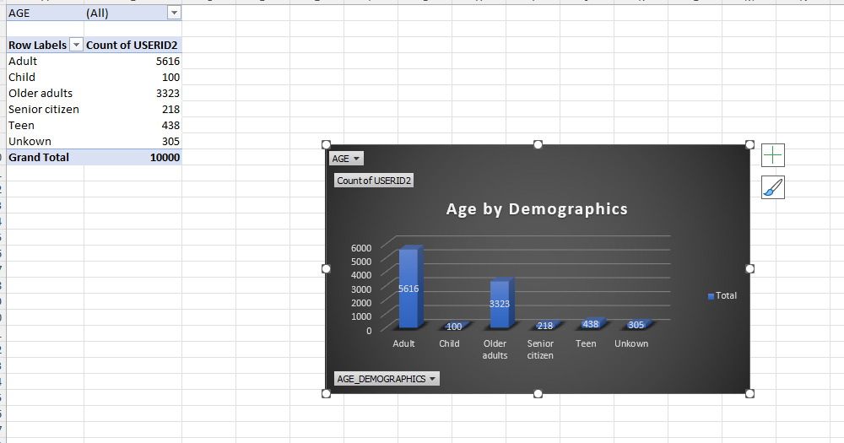

Lets Analyse : Province

**Pivot Rows:** Province, **Pivot Values**: Count of USERIDS2 : Bar Chart , **Pivot Columns** : Genre

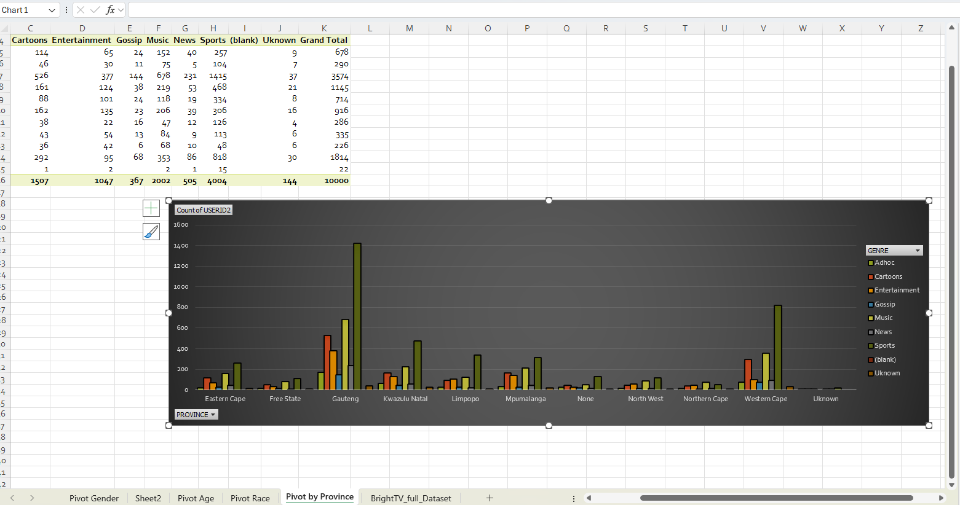

Lets Analyse : Race

**Pivot Rows:** Race, **Pivot Values**: Count of USERIDS2 : Pie Chart

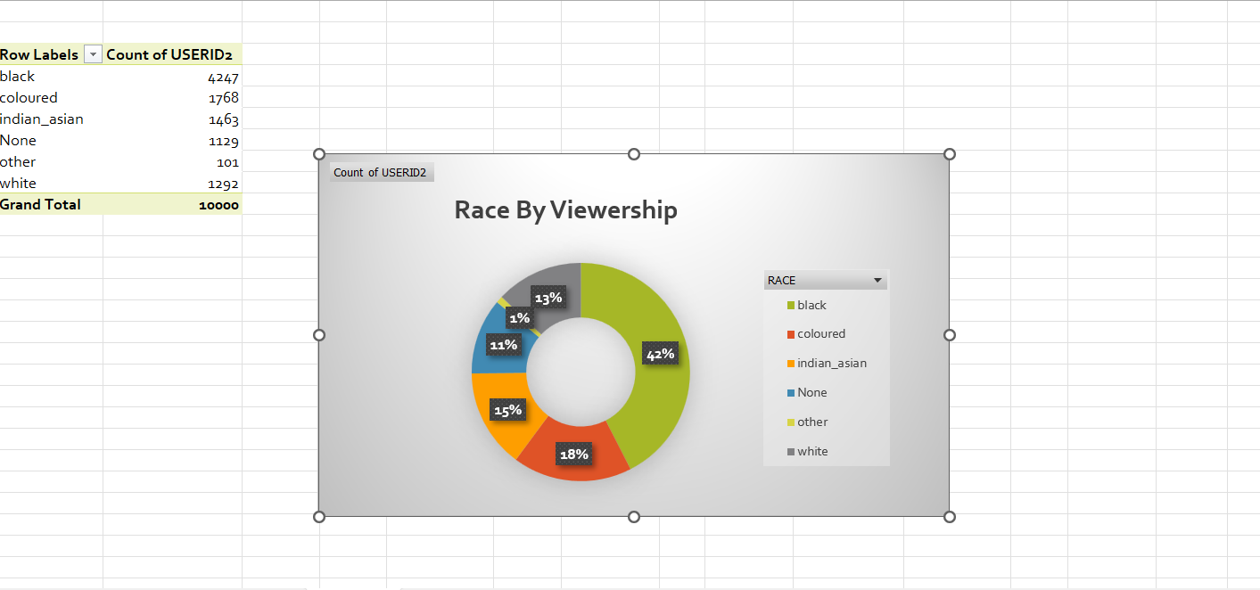

For Further Analysis I have segmented “Race” to provide me with the data by the **genre Channels Watched**

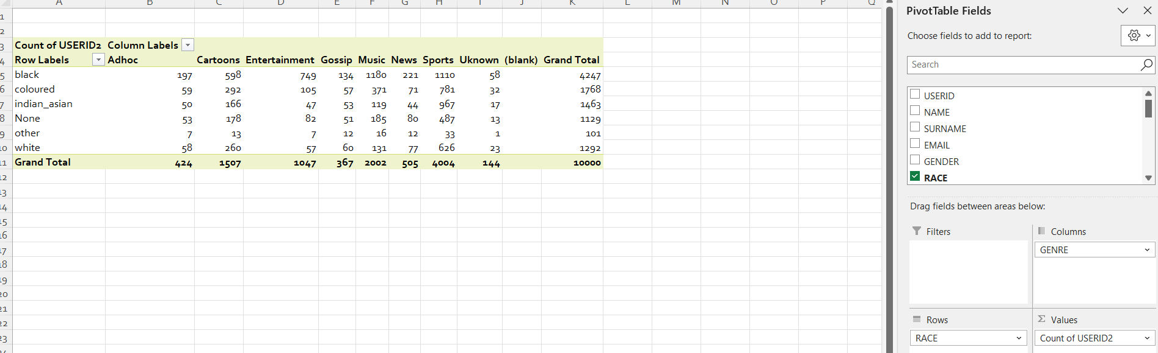

For Further Analysis I have segmented “Province ” to provide me with the data by the **genre Channels Watched**

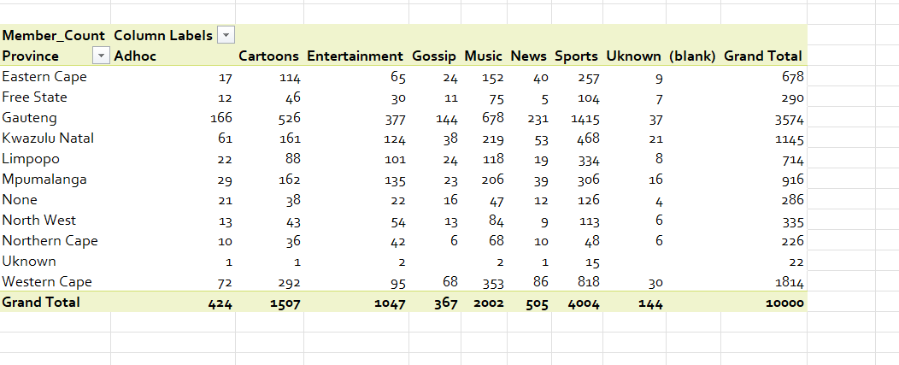

For Further Analysis I have segmented **“Popular time”** to analysis Viewers Habits

